**POST OFFICE PROTOCOL (POP3)**

Write a java program to implement pop3 protocol

**AIM**

To implement a pop3 protocol by reading the inbox of the mailbox providing the username and the password.

**ALGORITHM:**

1.START

2.Set up properties for Mail Session.

3.Create a Javax.mail Authenticator Object.

4.Create a Mail Session.

5.Get POP3 store provider and connect to the store of the mail.

6.Get folder and open INBOX folder in the store.

7.Retrieve message from folder.

8.Stop listening until user enter “STOP” .

9.STOP

**SOURCE CODE**

package com.sendemail;

import javax.mail.*;

import java.util.*;

import java.util.Properties;

class ReadEmail {

public static final String *USERNAME* = "machinelearning1308@gmail.com";

public static final String *PASSWORD* = "mbAbi@13!";

public static void func() throws Exception {

Properties props = new Properties();

props.put("mail.pop3.socketFactory.class", "javax.net.ssl.SSLSocketFactory");

props.put("mail.pop3.socketFactory.fallback", "false");

props.put("mail.pop3.socketFactory.port", "995");

props.put("mail.pop3.port", "995");

props.put("mail.pop3.host", "pop.gmail.com");

props.put("mail.pop3.user", ReadEmail.*USERNAME*);

props.put("mail.store.protocol", "pop3");

Authenticator auth = new Authenticator() {

@Override

protected PasswordAuthentication getPasswordAuthentication() {

return new PasswordAuthentication(ReadEmail.*USERNAME*, ReadEmail.*PASSWORD*);

}

};

Session session = Session.*getDefaultInstance*(props, auth);

Store store = session.getStore("pop3");

store.connect("pop.gmail.com", ReadEmail.*USERNAME*, ReadEmail.*PASSWORD*);

Folder inbox = store.getFolder("INBOX");

inbox.open(Folder.*READ_ONLY*);

Scanner inp = new Scanner(System.*in*);

Message[] messages = inbox.getMessages();

for (Message message : messages) {

message.writeTo(System.*out*);

System.*out*.print("\nDo you want to continue ?? ");

String st = inp.nextLine();

if (st.equalsIgnoreCase("no"))

{

System.*out*.println("\n\nINBOX MESSAGES READ SUCCESSFULLY !!\n");

break;

}

}

// 7. Close folder and close store.

inbox.close(false);

store.close();

}

}

public class SendMail{

public static void main(String[] args) throws Exception {

System.*out*.println("Welcome "+ReadEmail.*USERNAME*.split("@")[0]);

System.*out*.println("\nReceiving Inbox Messages...\n");

ReadEmail.*func*();

}

}

**OUTPUT**

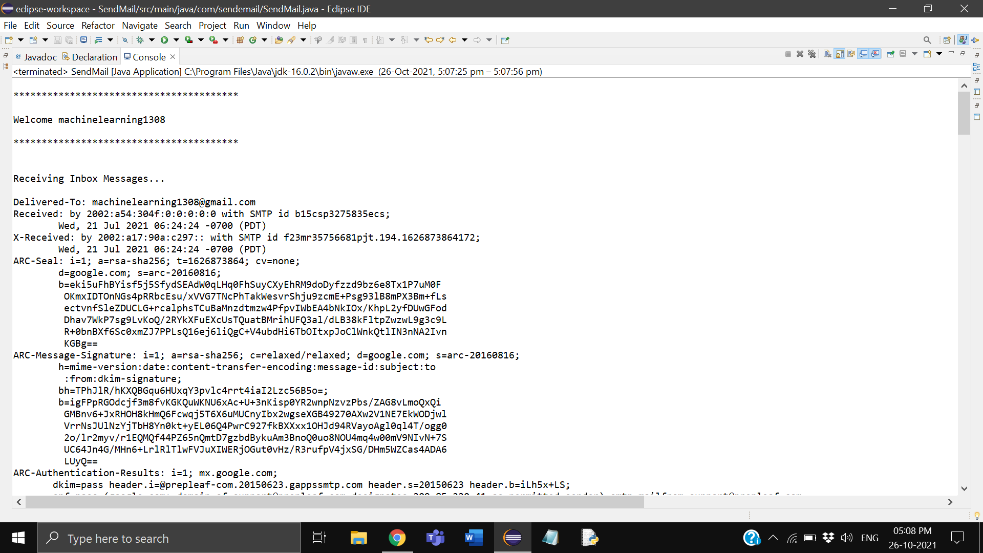

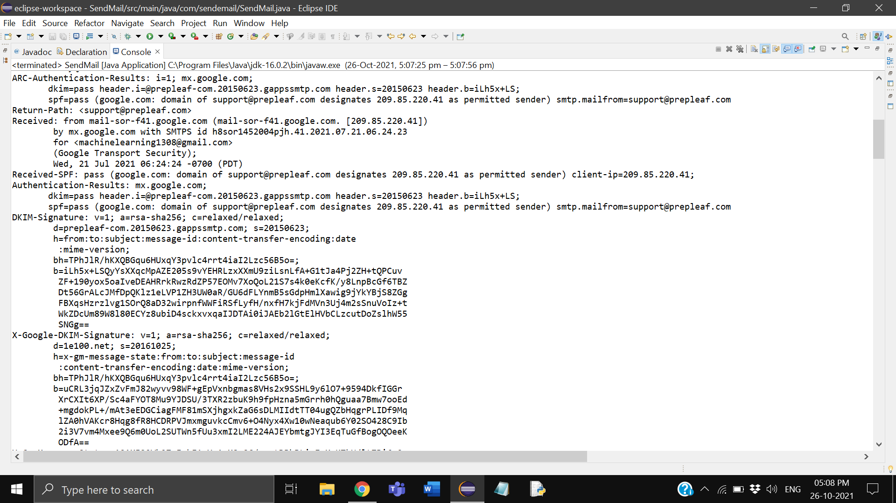

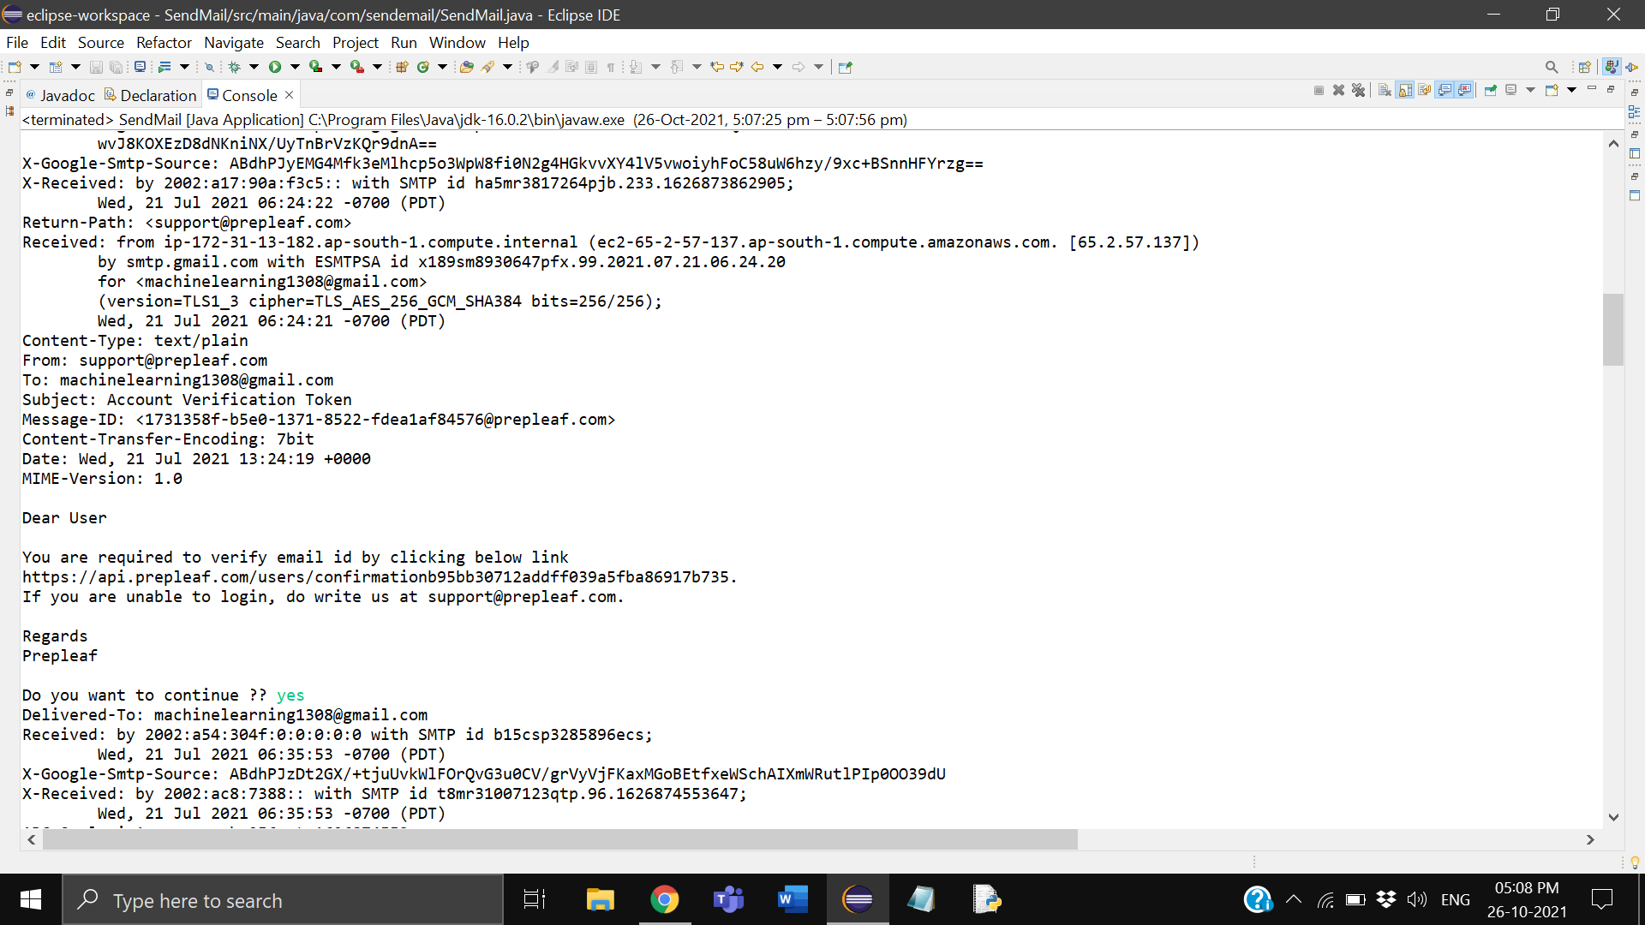

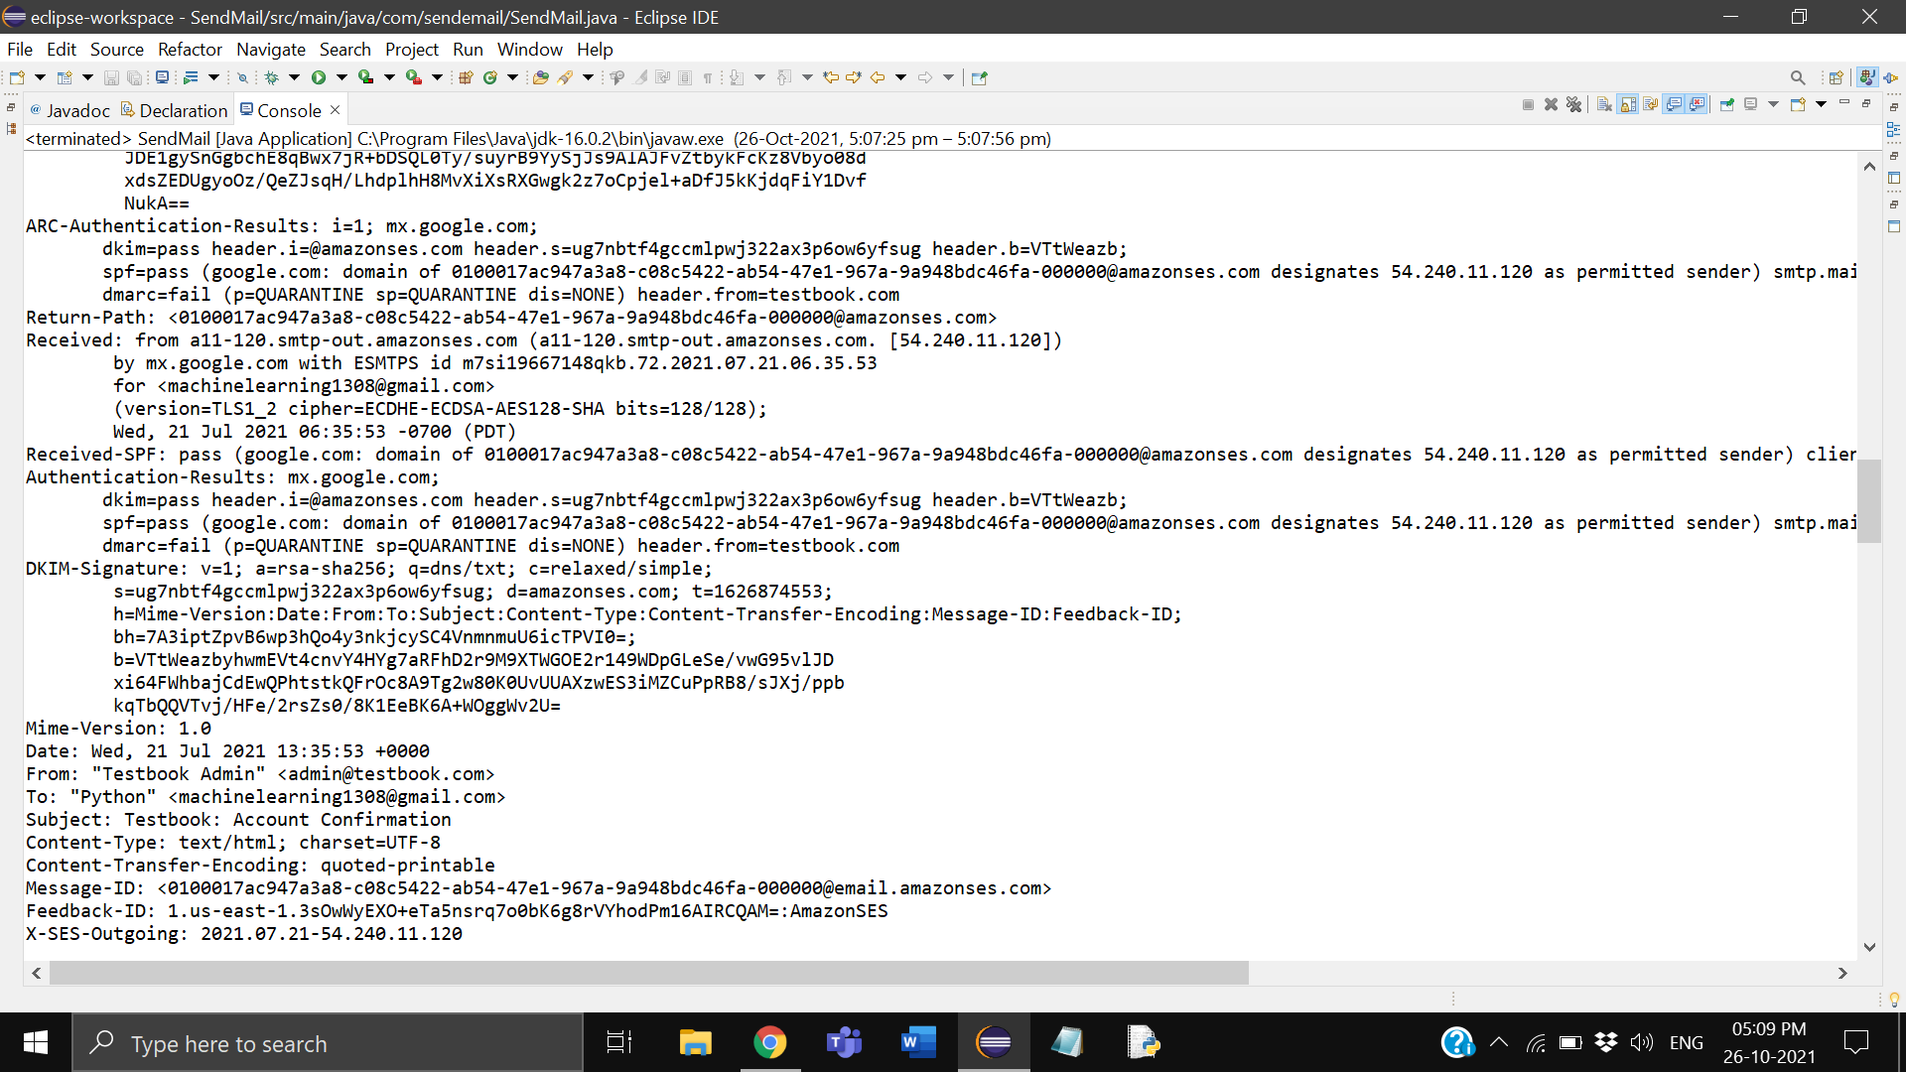

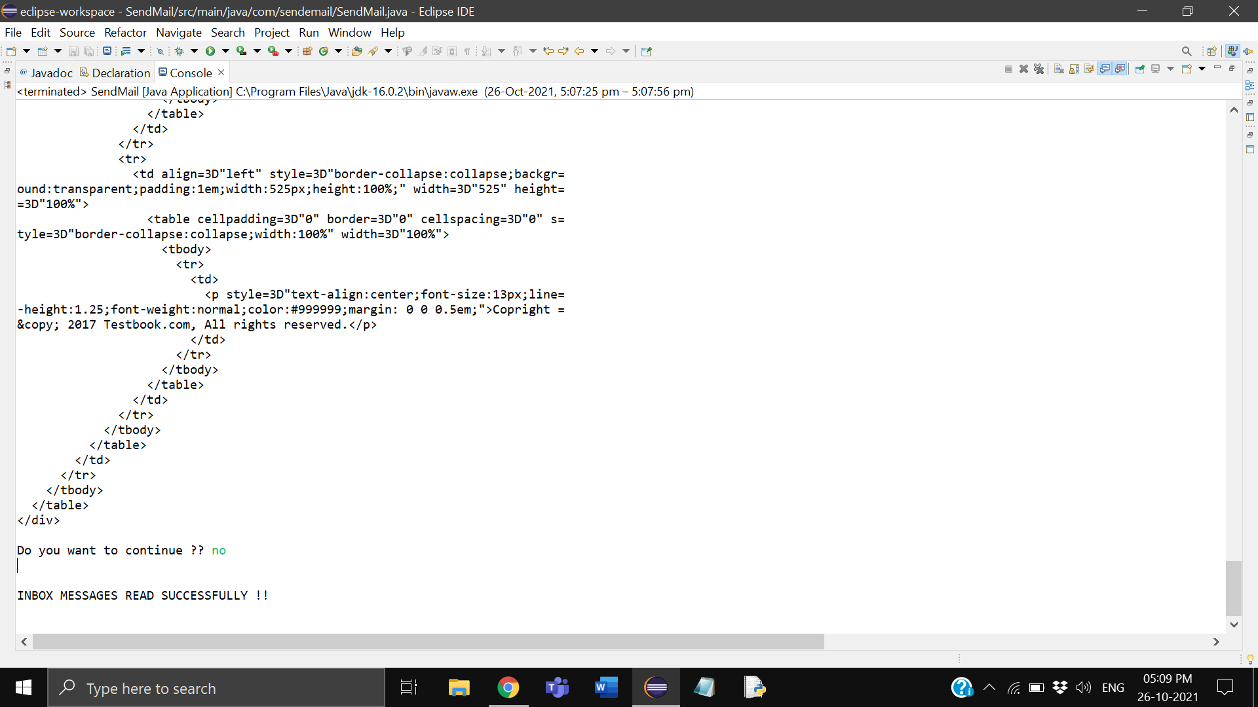

**RESULT**

Hence java program is implemented using pop3 protocol